**STATISTICAL TEST (Mann Whitney test):**

**CASE 1:**

**H0:** There is no significant differences in the YearsAtCompany between attrition (Y) and attrition (N)

**Ha:** There is significant differences in the YearsAtCompany between attrition (Y) and attrition (N)



Here the **p value is less than 0.05** so **Null Hypothesis** is **rejected** and **Alternative Hypothesis is accepted**

**There is significance difference in YearsAtCompany** **between attrition (yes) and attrition (no)**

**CASE 2:**

**H0:** There is no significant differences in the Education between attrition (Y) and attrition (N)

**Ha:** There is significant differences in the Education between attrition (Y) and attrition (N)

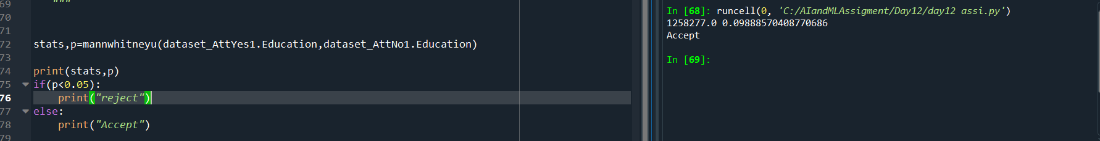

Here the **p value is greater than 0.05** so **Null Hypothesis** is **accepted** and **Alternative Hypothesis is rejected**

**There is no significance difference in Education between attrition (yes) and attrition (no)**

**CASE 3:**

**H0:** There is no significance difference in distance from home between attrition (yes) and attrition (no)

**Ha:** There is significance difference in distance from home between attrition (yes) and attrition (no)



Here the **p value is greater than 0.05** so **Null Hypothesis** is **accepted** and **Alternative Hypothesis is**

**There is no significance difference in distance from home between attrition (yes) and attrition (no)**

**CASE 4:**

**H0:** There is no significant differences in the MonthlyIncome between attrition (Y) and attrition (N)

**Ha:** There is significant differences in the MonthlyIncome between attrition (Y) and attrition (N)



Here the **p value is greater than 0.05** so **Null Hypothesis** is **accepted** and **Alternative Hypothesis is rejected**

**There is no significance difference in MonthlyIncome between attrition (yes) and attrition (no)**

**CASE 5:**

**H0:** There is no significant differences in the PercentSalaryHike between attrition (Y) and attrition (N)

**Ha:** There is significant differences in the PercentSalaryHike between attrition (Y) and attrition (N)

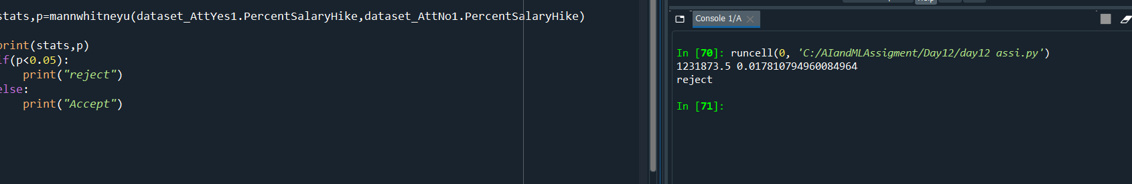

Here the **p value is less than 0.05** so **Null Hypothesis** is **rejected** and **Alternative Hypothesis is accepted**

**There is significance difference in PercentSalaryHike** **between attrition (yes) and attrition (no)**

**CASE 6:**

**H0:** There is no significant differences in the TotalWorkingYears between attrition (Y) and attrition (N)

**Ha:** There is significant differences in the TotalWorkingYears between attrition (Y) and attrition (N)



Here the **p value is less than 0.05** so **Null Hypothesis** is **rejected** and **Alternative Hypothesis is accepted**

**There is significance difference in TotalWorkingYears** **between attrition (yes) and attrition (no)**

**CASE 7:**

**H0:** There is no significant differences in the YearsWithCurrManager between attrition (Y) and attrition (N)

**Ha:** There is significant differences in the YearsWithCurrManager between attrition (Y) and attrition (N)



Here the **p value is less than 0.05** so **Null Hypothesis** is **rejected** and **Alternative Hypothesis is accepted**

**There is significance difference in YearsWithCurrManager** **between attrition (yes) and attrition (no)**

**Another Test Case:**

**STATISTICAL TEST (Separate T Test):**

**CASE 1:**

**H0:** There is no significant differences in the YearsAtCompany between attrition (Y) and attrition (N)

**Ha:** There is significant differences in the YearsAtCompany between attrition (Y) and attrition (N)

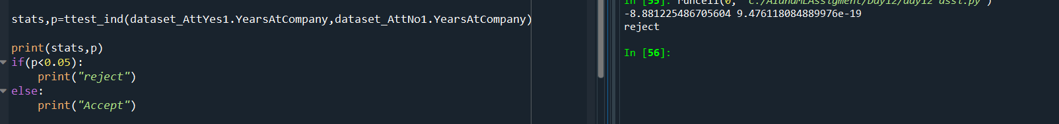

Here the **p value is less than 0.05** so **Null Hypothesis** is **rejected** and **Alternative Hypothesis is accepted**

**There is significance difference in YearsAtCompany** **between attrition (yes) and attrition (no)**

**CASE 2:**

**H0:** There is no significant differences in the DistanceFromHome between attrition (Y) and attrition (N)

**Ha:** There is significant differences in the DistanceFromHome between attrition (Y) and attrition (N)



Here the **p value is greater than 0.05** so **Null Hypothesis** is **accepted** and **Alternative Hypothesis is**

**There is no significance difference in distance from home between attrition (yes) and attrition (no)**

**CASE 3:**

**H0**: There is no significant differences in the YearsWithCurrManager between attrition (Y) and attrition (N)

**Ha:** There is significant differences in the YearsWithCurrManager between attrition (Y) and attrition (N)

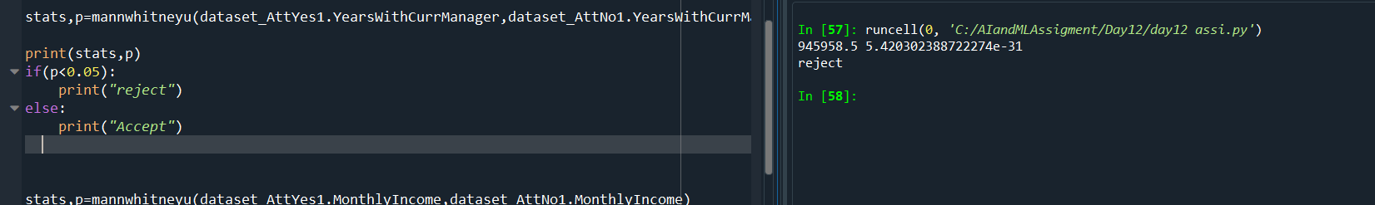

Here the **p value is less than 0.05** so **Null Hypothesis** is **rejected** and **Alternative Hypothesis is accepted**

**There is significance difference in YearsWithCurrManager** **between attrition (yes) and attrition (no)**

**CASE 4:**

**H0:** There is no significant differences in the TotalWorkingYears between attrition (Y) and attrition (N)

**Ha:** There is significant differences in the TotalWorkingYears between attrition (Y) and attrition (N)TotalWorkingYears



Here the **p value is less than 0.05** so **Null Hypothesis** is **rejected** and **Alternative Hypothesis is accepted**

**There is significance difference in TotalWorkingYears** **between attrition (yes) and attrition (no)**